Year 12 Examination, 2017

Question/Answer Booklet

MATHEMATICS SPECIALIST

Section One: Calculator-free

Student Name/Number: ______________________________________________

Teacher Name: ______________________________________________

Time allowed for this section
Reading time before commencing work: five minutes
Working time for this section: fifty minutes

Materials required/recommended for this section
To be provided by the supervisor: This Question/Answer Booklet
Formula Sheet

To be provided by the candidate:
Standard items: pens (blue/black preferred), pencils (including coloured), sharpener,
correction fluid/tape, eraser, ruler, highlighters
Special items: nil

Important note to candidates
No other items may be taken into the examination room. It is your responsibility to ensure that you do not have any unauthorised notes or other items of a non-personal nature in the examination room. If you have any unauthorised material with you, hand it to the supervisor before reading any further.

Structure of this paper

Section | Number of questions available | Number of questions to be answered | Working time (minutes) | Marks available | Percentage of exam
Section One: Calculator-free | 7 | 7 | 50 | 54 | 35
Section Two: Calculator-assumed | 11 | 11 | 100 | 100 | 65
 |  |  |  |  | 100

Instructions to candidates

- The rules for the conduct of School exams are detailed in the _______________________________________School/College assessment policy. Sitting this examination implies that you agree to abide by these rules.

- Write your answers in this Question/Answer Booklet.

3. You must be careful to confine your responses to the specific questions asked and to follow any instructions that are specific to a particular question.

- Spare pages are included at the end of this booklet. They can be used for planning your responses and/or as additional space if required to continue an answer.
  - Planning: If you use the spare pages for planning, indicate this clearly at the top of the page.
  - Continuing an answer: If you need to use the space to continue an answer, indicate in the original answer space where the answer is continued, i.e. give the page number. Fill in the number of the question that you are continuing to answer at the top of the page.

- Show all working clearly. Your working should be in sufficient detail to allow your answers to be checked readily and for marks to be awarded for reasoning. Incorrect answers given without supporting reasoning cannot be allocated any marks. For any question or part question worth more than two marks, valid working or justification is required to receive full marks. If you repeat any question, ensure that you cancel the answer you do not wish to have marked.

- It is recommended that you do not use pencil, except in diagrams.

- The Formula Sheet is not to be handed in with your Question/Answer Booklet.

Section One: Calculator-free 35% (54 Marks)

This section has seven (7) questions. Answer all questions. Write your answers in the spaces provided.

Spare pages are included at the end of this booklet. They can be used for planning your responses and/or as additional space if required to continue an answer.
- Planning: If you use the spare pages for planning, indicate this clearly at the top of the page.
- Continuing an answer: If you need to use the space to continue an answer, indicate in the original answer space where the answer is continued, i.e. give the page number. Fill in the number of the question that you are continuing to answer at the top of the page.

Suggested working time: 50 minutes.

Question 1 (4 marks)

Solve the differential equation
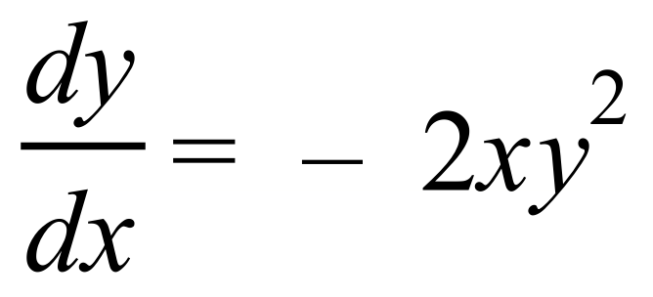
given that

Question 2 (6 marks)

Sketch the function paying particular attention to the location of its turning point(s) and the behaviour as.

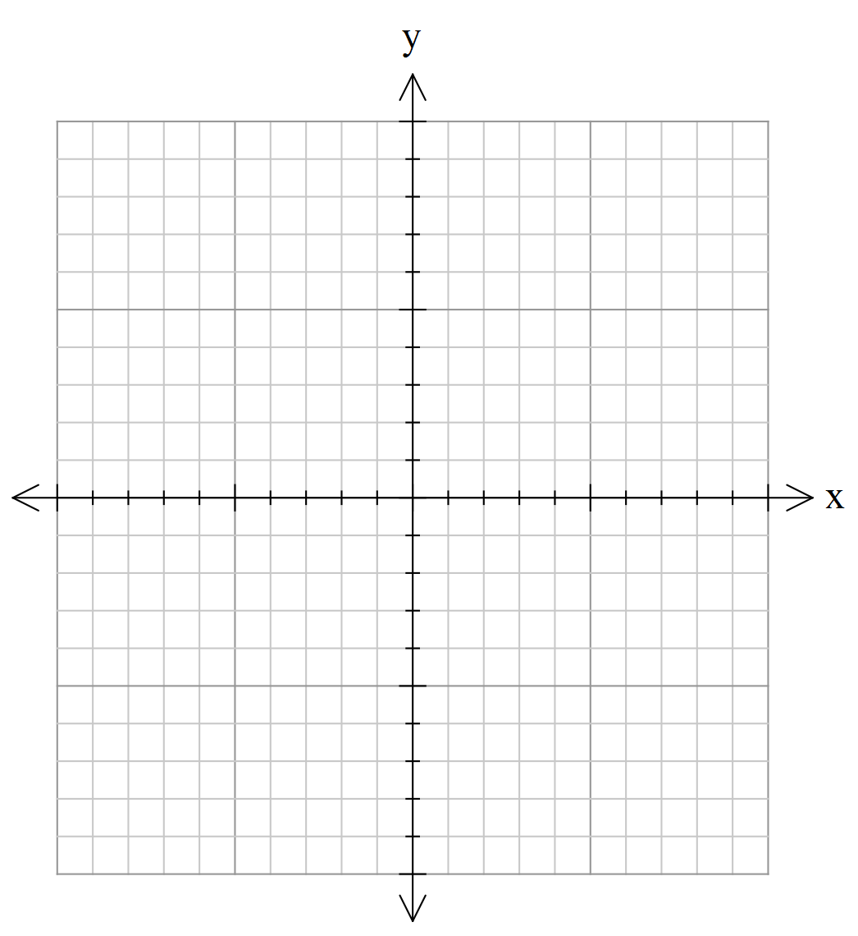

Question 3 (8 marks)

- Determine the two points P and Q where the curve
cuts the-axis. (2 marks)

- Show that the tangents to the curve at P and Q are parallel. (4 marks)

- The point R on the curve has co-ordinate 2.99. Use increments to deduce an approximation for the co-ordinate of R. (2 marks)

Question 4 (7 marks)

The positions in the complex plane of the numbers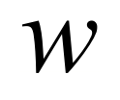andtogether with the unit circle are shown below.

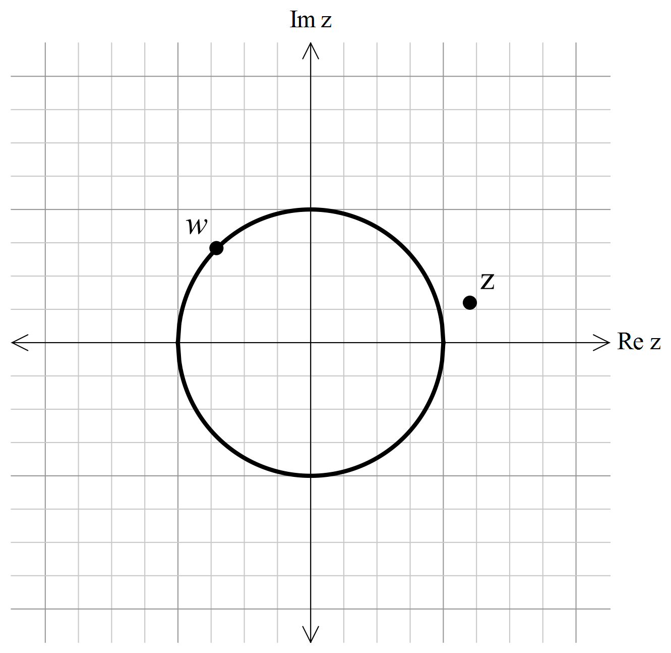

- Indicate, as accurately as possible, the positions in the complex plane of the numbers:

- (1 mark)

- (1 mark)

- (1 mark)

- (1 mark)

- (1 mark)

- Sketch on the diagram the set of complex numbers which satisfy both the inequalities

and . (2 marks)

Question 5 (12 marks)

Determine the following integrals:

- (3 marks)

- . (3 marks)

- Use the substitution to evaluate (3 marks) .

- Use the substitution to determine the value of if
. (3 marks)

Question 6 (8 marks)

- The formula for a confidence interval for the mean of a population is often expressed in the form

where is the sample mean and  is called the ‘margin of error’.
Write down a formula for  assuming that the sample mean is normally distributed and the standard deviation of the population is known. (1 mark)

- Describe the effect on the margin of error if

- the sample size doubles. (1 mark)

- the level of confidence increases. (1 mark)

- the standard deviation of the underlying population doubles. (1 mark)

- State whether the following statements about confidence intervals for are true or false. Justify your answers.

- If there are 10 independent samples from the same population, then exactly 9 of the corresponding 90% confidence intervals will contain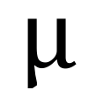. (2 marks)

- Each 95% confidence interval for contains 95% of the underlying population.
(2 marks)

© MAWA, 2016
This examination is Copyright but may be freely used within the school that purchases this licence.
- The items that are contained in this examination are to be used solely in the school for which they are purchased.
- They are not to be shared in any manner with a school which has not purchased their own licence.
- The items and the solutions/marking keys are to be kept confidentially and not copied or made available to anyone who is not a teacher at the school. Teachers may give feedback to students in the form of showing them how the work is marked but students are not to retain a copy of the paper or the marking guide until the agreed release date stipulated in the purchasing agreement/licence.
Published by The Mathematical Association of WA
12 Cobbler Place, MIRRABOOKA 6164.

Question 7 (9 marks)

Two vectors are defined to be
For some scalar value , the vector is orthogonal to .

- Determine the value of. (3 marks)

- Determine the equation of the line parallel to c that passes through the origin. Express the equation of the line in both vector and parametric forms. (2 marks)

- Determine the vector product of and . (2 marks)

- Write down the equation of the plane that is perpendicular to both and and that contains the origin. (2 marks)

Additional working space
Question number: __________________

Additional working space
Question number: __________________

Acknowledgements

© MAWA, 2017
This examination is Copyright but may be freely used within the school that purchases this licence.
- The items that are contained in this examination are to be used solely in the school for which they are purchased.
- They are not to be shared in any manner with a school which has not purchased their own licence.
- The items and the solutions/marking keys are to be kept confidentially and not copied or made available to anyone who is not a teacher at the school. Teachers may give feedback to students in the form of showing them how the work is marked but students are not to retain a copy of the paper or the marking guide until the agreed release date stipulated in the purchasing agreement/licence.
Published by The Mathematical Association of WA
12 Cobbler Place, MIRRABOOKA 6164.

